Evaluación de la investigación sobre la pedagogía Construcción de Conocimiento: un enfoque metodológico mixto

Evaluation of research on the Knowledge Building pedagogy: a mixed methodological approach

Resumen

La Construcción de Conocimiento (CC) es un marco teórico que promueve la indagación colectiva para resolver problemas del conocimiento relevantes en una comunidad educativa. Hay un número cada vez mayor de autores que buscan los beneficios de este enfoque, por lo que se necesita una visión general de las tendencias de la investigación. El objetivo de este estudio es proporcionar el estado del arte relacionado con la producción de investigación sobre la pedagogía de la Construcción de Conocimiento, incluidas las tendencias y temas relevantes. En este estudio se aplicó un diseño explicativo secuencial que combina los enfoques cuantitativos (análisis cienciométrico) y cualitativos (revisión sistemática). La muestra se seleccionó de las producciones más recientes publicadas en revistas indexadas en la base de datos Web of Science. El análisis cienciométrico muestra una dinámica de publicación típica de un campo de investigación emergente. En la fase cualitativa, el análisis revela las tendencias de investigación sobre la creación de conocimiento, así como los beneficios de ponerlo en práctica en una amplia gama de contextos, exponiendo que la tecnología es un componente relevante del aprendizaje basado en la pedagogía. Estos beneficios se refieren principalmente a la profundidad de pensamiento de los individuos y las habilidades de colaboración dentro de entornos de aprendizaje sostenidos por computadora.

Palabras Clave: Constructivismo Social; pedagogía Knowledge Building; análisis cienciométrico, revisión temática; métodos mixtos.

Abstract

Knowledge Building (KB) is a theoretical framework that promotes collective inquiry through the resolution of knowledge problems that are relevant for certain educational community. There is an increasing number of authors looking into benefits of this approach, thus an overview of the trends of research is needed. The aim of this study is to provide the state of the art concerning the research production on Knowledge Building pedagogy including trends and relevant issues. In this study a sequential explanatory design was applied. Both quantitative (scientometric analysis) and qualitative (systematic review) approaches were applied. The sample was selected from the most recent productions published in journals indexed in the Web of Science database. The scientometric analysis shows a publishing dynamics typical of an up and coming research field. In the qualitative phase, analysis reveals research trends on Knowledge Building as well as the benefits of putting it into practice in a wide range of contexts, exposing that technology is a relevant component of learning based on the pedagogy. These benefits mainly regard to individuals' depth of thinking and collaboration skills within computer supported environments.

Keywords: Social Constructivism, Knowledge Building pedagogy; scientometric analysis; systematic review.
Introduction

In today's societies, the democratization of innovation should be a priority of educational systems (Von Hippel, 2005). In this regard, Knowledge Building pedagogy is a framework that defends an education that aims to provide communities where students can collectively build artifacts to address knowledge problems (Bereiter & Scardamalia, 1987, 1993; Scardamalia & Bereiter, 1994). This educational approach is based on a trialogical approach to learning (Paavola & Hakkarainen. 2005). Unlike the monological approach that explores the cognitive processes, or the dialogic approach that examines internalization during peer interactions, the trialogical approach emphasizes the creation of artifacts. Under this perspective, knowledge is not transferred from a teacher to a student, but teacher advocates design thinking and critical thinking model for students developed responsibility and skills to build collective knowledge (Scardamalia & Bereiter, 2017).

In this way, KB pedagogy aims to facilitate communities where students can share ideas with others to solve real life problems for public good (Scardamalia, 2002). KB draws on the Popperian cosmology to explain the authentic knowledge work in communities (Chen & Hong, 2016; Scardamalia, 2002). Popper described three interacting worlds: World 1, the world of physical objects and events; World 2, the world of mental objects and events; and World 3, that contains objective conceptual artefacts created by human thoughts (Popper, 1972, 1994). The third world is home to knowledge exchange because we can capture knowledge in its form as a conceptual artefact, but we can also build on it, modify it and develop it even more. Creative and critical capacities of human (World 2) allow us to solve problems and, as a consequence, to produce new ideas in World 3. The science should not put in the centre the conceptualization of truth but the improvement of ideas (Thagard, 1989). Neither does the KB pedagogy (Bereiter, 2002). According to KB pedagogy, conceptual artifacts are built through a scientific discourse in such a way that ideas that are more resistant to criticism generated in World 2 are those that 'survive' in World 3.

Scardamalia (2002) proposed twelve principles to facilitate implementation of KB pedagogy. These principles can be organized into six categories. The first category, "expansive systematic knowledge", refers to the fact that this pedagogy focuses on the construction and continuous improvement of ideas to generate an integrated body of knowledge. The second category, "transcends the academic knowledge" mentions the importance of the focus on academic and real or authentic knowledge problems, those that are valuable in society. The third category, "the constructive discourse based on inquiry" points out that improvement of collective knowledge is feasible due to the constructive discourse. Through this constructive discourse, the members of the community formulate questions, theorize, design ways of testing their theories, and apply thinking strategies that facilitate ‘rising above’, i.e., the emergence of knowledge at a higher level. The fourth category is a concurrent, embedded, reflective and transformative assessment. The assessment is part of the effort to advance knowledge and is used to identify problems as the work progresses (Scardamalia, 2002). The fifth category, “collective cognitive responsibility”, refers to the fact that all members of the community should share responsibility during the process of knowledge building. From the KB perspective, the knowledge not only emanates from the teacher or authoritative sources, but is also generated from a constructive discourse among the members of the community. In other words, the intention of the KB approach is to achieve a ‘cognitive collective responsibility’; i.e., all the members of the community must share responsibility for the process of building ideas and the equi-distribution of ideas throughout the community by providing feedback to each other. (Scardamalia, 2002; Gutiérrez-Braojos, 2020; Gutiérrez-Braojos & Salmerón, 2015; Gutiérrez-Braojos, Montejo-Gamez, Ma, Chen, Scaradamalia & Bereiter, 2019). Finally, the sixth category, "socio-affective community", emphasizes the importance of developing an environment where participants feel safe when expressing their ignorance or receiving criticism.

Technology is crucial to put KB into practice (Gutiérrez-Braojos, Montejo-Gámez, Marín-Jiménez & Poza-Vilches, 2018). Accordingly, Chen & Hong (2016) refer to “KB theory, pedagogy, and technology” to point out the connection between these three dimensions of KB, that are connected to each other. Therefore, the development of suitable environments/tools is a challenge for the development of the pedagogy. With this aim, Scardamalia and his colleagues developed a virtual environment called Knowledge Forum (KF). This platform has the function of facilitating community agents to share and constructively discuss conceptual artifacts (Gutiérrez-Braojos, Montejo-Gamez, Marín-Jiménez & Campaña, 2019). Therefore, we could say that from the KB pedagogy, this platform is analogous to the World 3 in Popper's approach. The virtual environment Knowledge Forum (KF) is a software program developed by Scardamalia (2004), which is based on Computer Supported Intentional Learning Environments, CSILE (Scardamalia, Bereiter & Lamon, 1994). The Knowledge Forum allows asynchronous communication and collaboration to generate ideas through different interaction scaffolds (for example, "I need to understand", "a better theory").

Systematic reviews and scientometric studies on KB

Throughout this century, Knowledge Building pedagogy has been widely introduced as an innovative teaching practice in many educational environments. Concurrently, the research on this pedagogy has been developed in a great number of directions. Few studies have been directed toward the analysis of the progress and current state of the empirical research on KB in the education field. Chen & Hong (2016) carried out review of research to discuss this evolution of KB pedagogy from the point of view of the principles, as well as some theoretical questions and pedagogical challenges stemming from the investigation. Wu & Wand (2016) carried out a review of the characteristics and results of empirical studies on KB from 2006 to 2015. Recently Park & Park (2018) published a scientometric study which analyse keywords, themes, authors, core journal and cocitation from 1997 to 2016. Nevertheless, no study has carried out a scientometric analysis on emergent KB trends during the last years. An analysis of trends in recent years can indicate emerging trends of the research on the KB, without being influenced by data from older publications.

Research questions and objectives

The aim of this study is to provide an overview of the main trends on research production regarding the KB pedagogy. Several questions have to be addressed in this sense: What are the production dynamics like during the last years? Who are the most relevant authors? What are the educational settings of the studies on KB in recent years? Which are the research strategies applied to achieve their respective goals? What are the findings obtained by the KB research in recent years? To answer these questions, the following specific objectives are intended to be achieved:

- O1. To know production and consumption of research on KB in the set of educational thematic categories of the Web of Science (WoS), paying attention to diachronic evolution, institutions, authors, dynamics of authorship and contributions.
- O2. To find out the educational contexts where empirical studies on KB were carried out, paying special attention to participants, subjects, instructional designs, and the technology employed.
- O3. To examine useful methodologies as well as the role of technology to explore effects of KB, including strategies of data gathering and duration of research.
- O4. To sketch conclusions about the use of KB pedagogy and advancements in the theory: pros and cons found by the investigation, the role of technology as well as strengths and limitations pointed out by the authors.

Methods

It is proposed a mixed design approach, which is based in two studies: a scientometric analysis and a systematic review of the productions indexed in the WoS impact databases of the Institute for Scientific Information. Concretely, a sequential explanatory design was applied (Creswell, 2013), which consists of two chronological strands. Quantitative data were collected and analyzed firstly for the scientometric analysis, in order to achieve the objective O1. Secondly, objectives O2-O4 were addressed via the systematic review. Each of them, scientometric analysis (e.g. Aliaga, 1999; Bueno & Fernández-Cano, 2003; Fernádez-Bautista, Torralbo & Fernández-Cano, 2014; Fonseca-Mora & Aguaded, 2014) and systematic review (e.g. Fernández, Ruiz-Corbella & Galán, 2017; Moher & Liberati, 2010), has great potential to provide valuable input to support future research. Some authors have pointed out the limitations of evaluating production exclusively from scientometric indicators (Aliaga, Gutiérrez-Braojos & Fernández-Cano, 2018). Both approaches together they could generate more extensive insights that lead to an evolution of knowledge in an educational discipline or object of study.

Methods for the scientometric analysis

The target population of the study consisted of the contributions on KB published in journals indexed in the areas of education according to the SSCI (Social Sciences Citation Index) and SCIE (Science Citation Index Expanded) databases in the WoS. The following categories were included: Education & Educational Research; Education, Scientific Disciplines; Education, Special; Psychology, Educational; Psychology, Developmental. The data-gathering process began with a preliminary search to explore the number of productions appearing in the SSCI and SCIE databases from 1975 to November 2017 that included the term ‘Knowledge Building’ in the title. Results provided 188 productions. One month later, the process was replicated, and it yielded the same set of productions. The most relevant authors among these 188 productions were selected as follows. (i) The productions were ordered according to the impact factor of the journal in which they were published. (ii) Those productions whose position was above the 95th percentile (the first ten) were selected as the most relevant papers. (iii) The authors of these papers were considered to be the most relevant ones. Thus, 65 contributions of these relevant authors were added to the sample, giving rise to a new set of 253 productions. Because the study is focused on the trends in the research, a new phase was applied in order to select a sample composed of 101 productions published from January 2013 to December 2017. After a first screening that paid attention to citations, keywords, and constructs used, 15 productions were removed from the data. These were research contributions that were not focused on KB pedagogy, but rather on other topics. The remaining productions constitute the final sample, composed of 86 items (62 empirical and 24 theoretical).

In what regards the variables used and with the aim of perform a diachronic analysis, the total numbers of contributions per year were calculated. In order to investigate production and consumption, the scientometric indicators taken into account were the following (Gutiérrez-Braojos, Marín, Casasempere & Fernández-Cano, 2015; Gutiérrez-Braojos, Marin, Salmerón, Casasempere & Fernández-Cano, 2017): number of productions and percentage; citations received; impact index and impact index-based rank. These indicators were grouped by institution, and author, respectively. In particular impact index was calculate for institutions and authors. For this, we apply an ad hoc index, i.e., the sum of citations given by papers published by “X” (institution/author) in a period of years (Δt) divided by papers published by X (institution/author) in Δt. Moreover, the comparison of the empirical data with Lotka (1926) and Price’s (1976, 1986) distributions of authorship was based on the proportion of authors with a fixed number of contributions. In order to explain the dynamics of the publishing population, the reference year for the analysis was 2015. In this way, the flows of authorship (the amounts of authors who publish every year, stop publishing one year in the period, etc., see definitions below) were described by percentages with respect to the publishing authors in 2015. For instance, if there were 30 publishing authors in 2015 and 45 in 2016, the amount of authors who published in 2016 was represented by 150%. Finally, personal collaboration was measured using the number of signatures per study. In addition, we identify the authors who collaborate most frequently with each other.

Regarding the analytical procedure, data were organized using Excel and SPSS software. To do so, attention was paid to the basic WoS bibliographical fields (title of the document, year, authors, institution, titles of the journals, publisher, language, bibliographical references, keywords, citations received, scientific area, sample, and country). Other matrixes were created of data derived from the original matrix in order to analyze the data and respond to the different objectives pointed out (e.g. the symmetrical collaboration matrix).

Methods for the systematic review

Regarding the sample for the purposes of the systematic review, the 24 theoretical contributions were removed from the 86 items considered in the scientometric analysis. Later on, a subset was chosen randomly from the remaining papers, in such a way that contributions from every year were equally represented. The final sample is composed of 45 studies, i.e., 72.5% of the empirical research on KB indexed in SSCI and SCI databases from 2013 to 2017.

In order to address specific objectives, a content analysis of contributions in the sample was performed. It was carried out through a systematic review of each paper based on a checklist that included the variables of the qualitative study; (i) country, educational level, number of participants (mean and standard deviation), subject, instructional design, and technology employed were considered to deal with O2; (ii) research design/method, instruments, quantitative/qualitative analysis of data, validity/reliability strategies, and research duration were taken into account to reach O2; and (iii) results, conclusions, limitations, and further analyses suggested were observed to tackle O3.

It is noticeable that dealing with these objectives entails analyses of some objective data (countries, educational levels, subjects, strategies of data gathering and duration). These consisted of a process of counting and representing of information. For the remaining purposes, the qualitative analyses were carried out according to the scheme displayed in Figure 1 (Rodríguez, Gil & García, 1996). It represents two main steps: pre-analytical phase and analytical phase. In the pre-analytical phase, researchers designed the database and included the information about the papers in the sample. The input in the database was organized around several dimensions that were fixed according the sections of a research paper (abstract, introduction, theoretical framework, methodology, results, and conclusions). At this step, a provisional analysis is proposed attending to these dimensions. For each one of them, an inductive coding process started, which gave rise to a set of codes. These codes were the starting point for the analytical phase, where a deductive process took place. During this process, deductive coding refined previous (inductive) analysis. Two researchers independently started to characterize explanatory and descriptive representations that define the emerging categories, as well as the papers associated with them. Three main criteria for selecting and coding information were taken into account for both investigators. The first one is the thematic approach: paragraphs that concern the same topic allow unifying and defining categories. The second one is the criterion of relevance, which is connected to the presence of key ideas relevant for the KB pedagogy. Lastly, the criterion of affinity stands that coded texts should be grouped attending to related ideas. Once the categories were characterized, the two researchers established differentiated inferences and interpretations linked to each category. A triangulation process, where results were checked and integrated, was carried out afterwards. Once the results were put together, the remaining investigators looked over them and validated the process. Finally, conclusions regarding the objectives of the study were written in the report and reviewed.

FIGURE 1. Phases of the analytical process followed in the qualitative analysis
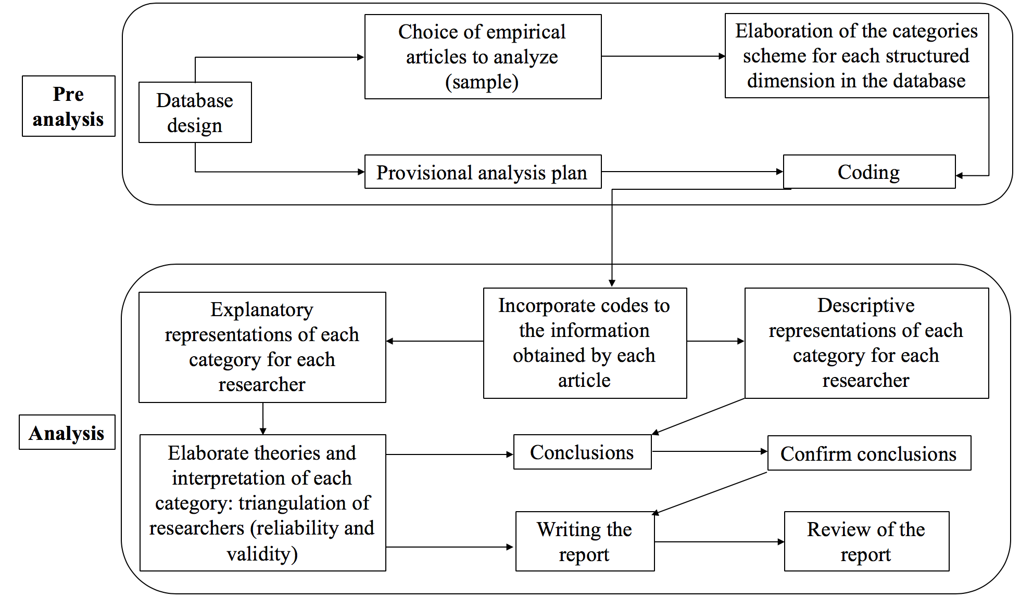
Source: Author (adapted from Rodríguez, Gil & García, 1996)

Results

Scientometric Analysis

Production and consumption of research on Knowledge Building

The first approach to the diachronic analysis showed that 77.91% of the sample is published in journal format, 11.63% is composed of conference papers, and the remaining contributions were published in books. The language most utilized was English: there is one paper written in German, whereas the remaining 85 of productions are in English. Among them, there is a research contribution that is available also in Spanish. The number of productions on KB during the last five years in the aforementioned categories from the WoS field of education was organized in year periods (Figure 2). The average number of productions per year is 17.2, with a standard deviation of 7.36; the maximum number of documents per year was 25 in 2016, and the minimum was 9 (2013), which shows that production is irregular. Thus, we do not find stages of Price’s growth law (1963). Therefore, the law of exponential growth formulated by Price does not explain the KB production during the past 5 years. However, these results could be due to the fact that data could not be obtained fully for 2017 at the time of this study. Another reason is that we have only analyzed five years, and other results might be found with a longer time frame.

FIGURE 2. Diachronic analysis of productivity about KB in education
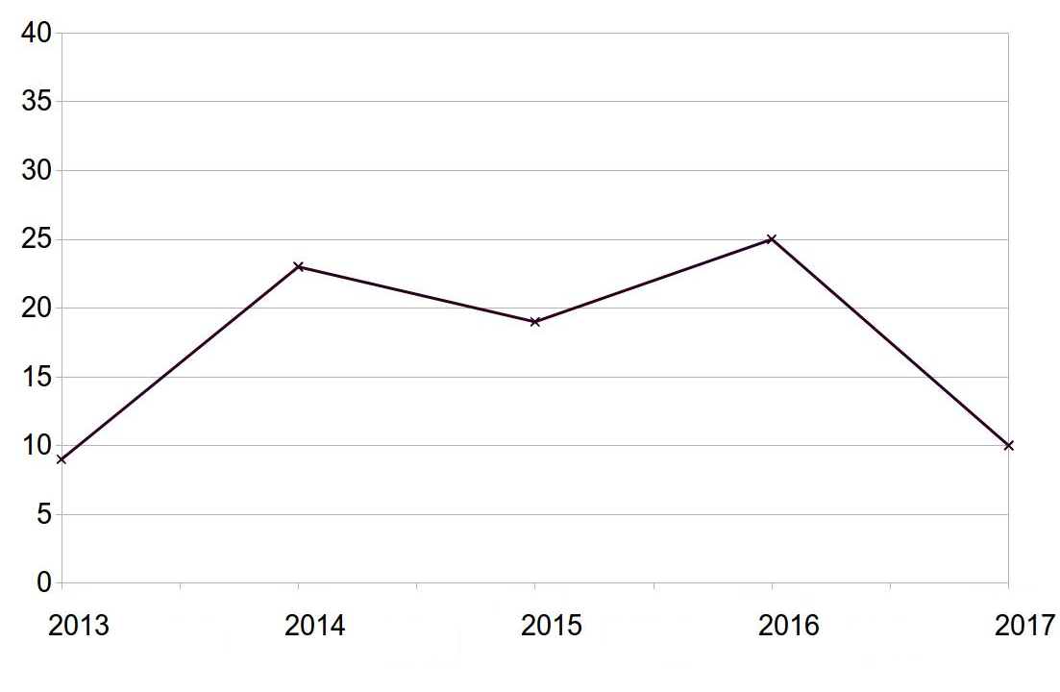

In what regards the institutions, a total amount of 86 have contributed with investigation about KB (Table 1). The most prolific institution is the ‘University of Toronto’ with 17 productions, followed by the ‘University of Tuebingen’ with 14 productions; the ‘National Chengchi University’ with 13 productions; and the ‘University of Hong Kong’ with 12 productions. The results of the consumption analysis show that the most productive institution is the one consumed most. i.e., University of Toronto. The results indicate that the institution with the highest impact is the ‘University of Illinois at Chicago’ (10 I.I.F.), followed by the ‘University of Tuebingen’ (8.36 I.I.F.), and University of Toronto (7.35 I.I.F.).

TABLE 1. Production and consumption of institutions
Institutions | Country | Productions | Citations | I.I.F. | I.I.F. Rank
University of Toronto | Canada | 17 | 125 | 7.35 | 3
University of Tübingen | Germany | 14 | 117 | 8.36 | 2
National Chengchi University | China | 13 | 39 | 3 | 7
University of Hong Kong | China | 12 | 39 | 3.25 | 6
National Institute of Education (Nanyang Technological University) | Singapore | 11 | 27 | 2.45 | 8
University of Minnesota-Twin Cities | EE.UU | 9 | 66 | 7.33 | 4
Drexel University | EE.UU | 4 | 16 | 4 | 5*
Oslo University | Norway | 4 | 16 | 4 | 5*
University of Illinois at Chicago | EE.UU | 3 | 30 | 10 | 1
Ministry of Education, Singapore | Singapore | 3 | 5 | 1.67 | 10
National Taiwan University of Science and Technology | Taiwan | 3 | 7 | 2.33 | 9
Note: Institutions with 2 productions or less have been omitted.
I.I.F. = Institutional Impact Index made ad hoc. * = shared rank.

As for the authors, a total of 197 researchers materialized investigations about KB. 33 of these researchers are exclusively editors (they did not write any contribution), according to SSCI and SCI databases. Thus, the other 164 authors were taken into account for the study. These include four people who played the role of both writer and editor. Hong and Scardamalia are the most productive writers, with 13 and 11 research outputs, respectively (Table 2). Regarding consumption, Bereiter and Scardamalia (Toronto) and Kimmerle (Tuebingen) are the most impacting authors, with an impact index of about 10. In this case, the most prolific authors are, roughly speaking, the most cited ones and with the highest impact value.

TABLE 2. Production and consumption of authors
Authors | Productions | Citations | A.I.I. | A.I.I. Rank
Hong, H. Y. | 13 | 39 | 3 | 6
Scardamalia, M. | 11 | 107 | 9.73 | 3
Chai, C. S. | 10 | 19 | 1.9 | 8
Cress, U. | 10 | 76 | 7.6 | 4
Bereiter, C. | 8 | 82 | 10.25 | 1
Chen, B. | 8 | 39 | 4.87 | 5
Law, N. | 7 | 20 | 2.86 | 7
Kimmerle, J. | 6 | 60 | 10 | 2
Note: Authors with 5 productions or less have been omitted. A.I.I. = Author Impact Index. * = shared rank.

Table 3 shows that the data do not fit Price's “square root” law (Price, 1963, see final note 1). Specifically, half of the contributions (43) were produced by just four of the authors, instead of 9 authors (as predicted by Price's law). Likewise, the Pareto principle is not followed by researchers in KB, given that 4.76% of the authors produced 86.05% of the contributions. Moreover, Table III was elaborated to explore the relationship between the observed production data and some classical models in scientometrics. On one hand, an optimal exponent of 2.711 was encountered for a Lokta-type model (Lotka, 1926), which is the best predictor of the production in KB. On the other hand, the best m=1.732 for a cumulative advantage model (Price, 1976, see final note 2) fails to approach the number of authors of few contributions. Likewise, the large number of authors with just one contribution in our sample seems to break down the fit to our data with regard to the classical price model (Price, 1986), where a value of 6 productions has been chosen to mark the boundary between very high and normal production in a five-year period.

TABLE 3. Empirical authorship distribution against predictions provided by classical models
Nº of contributions | Nº of authors | % of authors in the sample | % of authors by Lotka model | % predicted by a CA model | % predicted by Price model
1 | 137 | 81.55 % | 81.55% | 73.20% | 56.25%
2 | 15 | 8.93% | 12.45% | 15.47% | 17.82 %
3 | 4 | 2.38% | 4.15% | 5.40% | 8.43%
4 | 4 | 2.38% | 1.90% | 2.40% | 4.77%
5 | 0 | 0% | 1.04% | 1.24% | 3.01%
6 | 1 | .59% | .63% | .71% | 2.03%
7 | 1 | .59% | .42 % | .44% | 1.44%
8 | 2 | 1.19% | .29% | .29% | 1.06%
9 | 0 | 0% | .21% | .20% | .81 %
10 | 2 | 1.19% | .16% | .14% | .63%
11 | 1 | .59% | .12% | .10% | .50%
12 | 0 | 0% | .10% | .07% | .41%
13 | 1 | .59% | .08% | .06% | .33%

In order to understand the dynamics of production during the years 2013-2017, the authorship model proposed by Price (1986) was followed. The model, which is based on the idea of transience and continuance regarding certain research topic, focuses the attention on 2015 (Figure 3). That year 51 publishing authors, who contributed at least one paper, were found (thick border square in Figure 3). According to Price (1986), this set of researchers constitutes the reference population in order to calculate percentages, in such a way that the 164 contributors considered can be distributed into two big categories.

The main category is composed of the active population, which is constituted by the publishing authors in 2015 together with those contributors who published more than once during between 2013 and 2017 (rectangles on top of the square). This category amounts 57 individuals, i. e. 112% of the reference population. Within the publishing authors there are 12 publishing continuants (23%), who contributed at least one year before and after 2015. 2 of them (4%) constitute the core authors: Cress & Chai, who made a contribution every single year in the studied period.

There are also newcomers, who became publishers on KB pedagogy between 2013 and 2017. Among these, we can find 5 recruits (10% of the reference population and around 1/7 of the newcomers), who published at least one other year after 2015, and 32 transients (63% of the reference population and around 6/7 of the newcomers) who published that year and never again. The publishing authors’ group is completed with 2 terminating continuants (4%), who were continuant authors during the previous years and published that year but will not publish anymore. Terminating continuants along with transients make up the 'terminators' group of 34 individuals (67%) who finished their publishing activity in 2015. As for the set of researchers who contributed more than once in the period but they did not in 2015, there are 4 non-publishing continuants (8%), who did publish in a previous year or in a subsequent one. Moreover, 2 future recruits (4%), who started to publish in 2016 and also contributed in 2017, were found. However, data do not show any past terminator, i.e., a continuant who finished publishing before 2015. The second big category that completes the group of contributors of the study (at the top of figure 3) is made up by 107 transient authors (210%), who published just one paper in some year in the period taken into account (apart from 2015). Among them, 46 pasts transient (90%) and 61 future transient contributors (120%) were found out.

FIGURE 3. Dynamics of authorship according to Price's model.
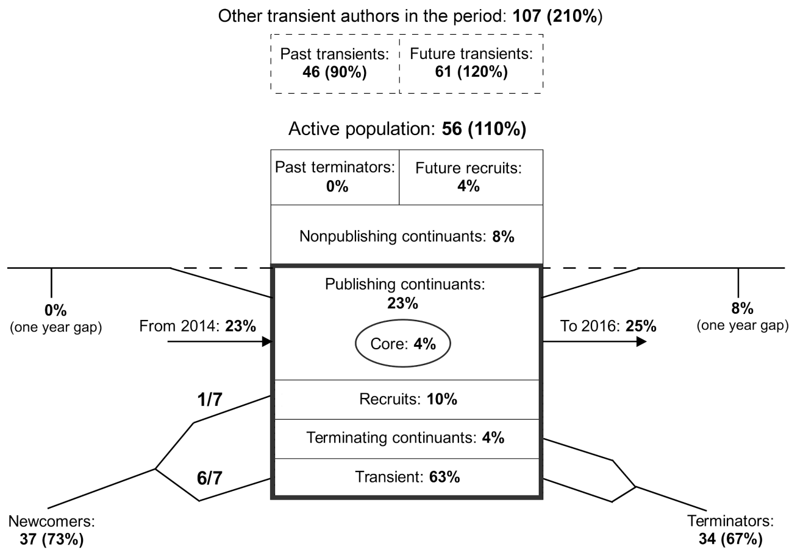
Source: own elaboration (Gutiérrez-Braojos, Montejo-Gamez, Marín-Jiménez & Campaña, 2019). Note: Percentages are expressed with regard to the publishing authors in 2015 and rounded to integers.

Figure 3 also shows how authorship flows around the year 2015. On one hand, 23% of the publishing authors in 2015 (21 contributors) had also contributed just in the previous year. On the contrary, nobody in the reference population made a contribution in 2013 and left a one-year gap before publishing in 2015. On the other hand, 25% of those publishing authors (13 researchers) also contributed just in the following year. Furthermore, 8% (4 authors) made a new contribution after one-year gap. To sum up, Price’s authorship model exposes high levels of transience and low levels of continuance of the KB research recorded by WoS in the analyzed interval.

Finally, in what concerns the contributions, Table 4 displays the consumption of the most popular productions between 2013 and 2017. At the top-10 of the list (with 25 citations) are the theoretical ones: ‘Managing, Understanding, Applying, and Creating Knowledge in the Information Age: Next-Generation Challenges and Opportunities’; and ‘Knowledge Building and Knowledge Creation: Theory, Pedagogy, and Technology’.

TABLE 4. Most impacting contributions about Knowledge Building and citations received
DOI | Authors | Citations | Type
10.1080/10824669.2013.773217 | Goldman, S. R. & Scardamalia, M. (2013) | 25 | T
10.1017/CBO9781139519526.025 | Scardamalia, M. & Bereiter, C. (1994) | 25 | T
10.1080/00461520.2015.1036273 | Kimmerle, J., Moskaliuk, J., Oeberst, A. & Cress, U. (2015) | 20 | T
10.1007/s11412-013-9182-3 | Halatchliyski, I., Moskaliuk, J., Kimmerle, J. & Cress, U. (2013) | 20 | E
10.1080/10508406.2014.888352 | Oeberst, A., Halatchliyski, I., Kimmerle, J. & Cress, U. (2014) | 19 | E
10.1080/10508406.2013.812533 | Bereiter, C. (2014) | 17 | T
10.1007/s11251-013-9283-4 | Roscoe, R. D. (2014) | 14 | E
10.1016/j.compedu.2013.09.009 | Hong, H-Y. & Scardamalia, M. (2014) | 14 | E
10.1007/s11412-015-9225-z | Chen, B. Scardamalia, M. & Bereiter, C. (2015) | 13 | E
10.1007/s11412-015-9219-x | Resendes, M., Scardamalia, M., Bereiter, C., Chen, B. & Halewood, C. (2015) | 13 | E
Note: T = theoretical contribution. E = empirical study.

The collaborations carried out to produce these 23 impacting contributions are shown in Table 5. The mode corresponds to productions that were signed by two or four researchers (30.43% of the total). As for the rest of the productions, 8.7% of the papers were published by one single author or five authors, whereas 17.39% of the contributions were conducted by three authors. In productions about KB, collaborations involving larger groups of authors are somewhat more unusual (4.34%). Data also show that authors who collaborate with each other more can be organized in two core groups. The first group of authors is composed of Bereiter & Scardamalia (University of Toronto) with 4 collaborations, and Chen (University of Minnesota) who participates in two of these productions. The second group of authors is made up of Cress & Kimmerle, with 3 collaborations, and Law, Halatchliyski, Moskaliuk, Oeberst, Stahl & Ludvigsen, who collaborate in two of these productions. The rest of the authors who wrote one of the highly consumed productions collaborated with other authors only once.

TABLE 5. Collaboration indices among Knowledge Building researchers to produce the most impacting papers
Nº of authors (a) | Nº of productions (b) | Percentages | Nº authors appearing (a×b)
12 | 1 | 4.34% | 12
5 | 2 | 8.7% | 10
4 | 7 | 30.43% | 28
3 | 4 | 17.39% | 12
2 | 7 | 30.43% | 14
1 | 2 | 8.7% | 2
Total | 23 | 100% | 78

Systematic Review

Educational contexts of research on Knowledge Building

Regarding the participants in KB studies, the results show that the mean sample size was 69.6 (SD 63.5). However, 50% of the checked papers worked with a sample with less than 50 individuals, whereas the modal value of the sample size is 22. Only Lin, Hong & Chai (2014), and Muhonen, Rasku-Puttonen, Pakarinen, Poikkeus & Lerkkanen (2017), with 1480 and 1862 participants, respectively, considered large samples. The rest of the works included samples from 9 to 308 students.

FIGURE 4. Countries and educational levels that were considered in the analyzed sample.
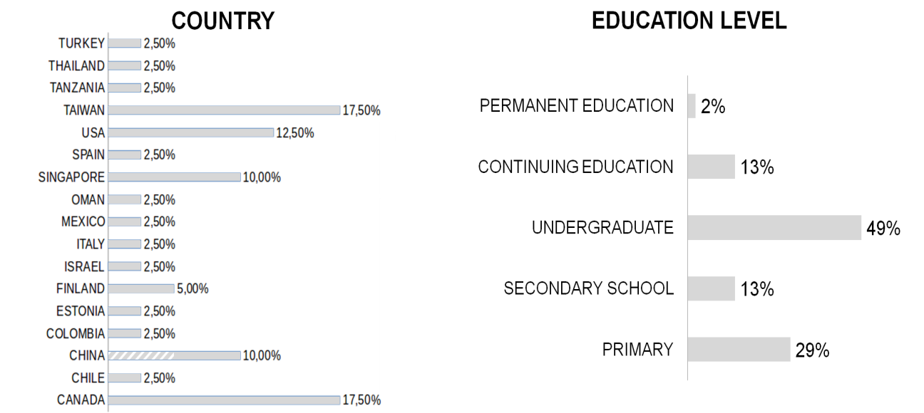
Note: Figure ad hoc. Investigations developed in Hong Kong are included in China (white-grey zone).

The remaining investigations took into account between 9 and 308 individuals. As for the countries, reviewed studies took place in 17 different countries, with Canada (17.5%) and Taiwan (17.5%) being the most relevant places. The full distribution is shown in Figure 4 (left). In relation to educational levels, almost 50% of the checked contributions worked with graduate students. There are also four studies that examined two different levels together (e.g. Lai & Law, 2013). Details about educational levels are included in Figure 4 (right).

The samples employed to implement KB pedagogy for research covered a wide range. Figure 5 displays the distribution of the papers organized in terms of the field of knowledge they were dealt with. The most investigated areas were Sciences (44% of the contributions) and Social and Legal Sciences (33.33%). There were also studies that were not focused on one single subject (11.11%) but analyzed KB transversally to different topics (e.g. Lai & Law, 2013 or Hong & Scardamalia, 2014). Finally, contributions on engineering, health sciences and humanities made up a minority.

Figure 5. Fields of knowledge considered in the analyzed sample.
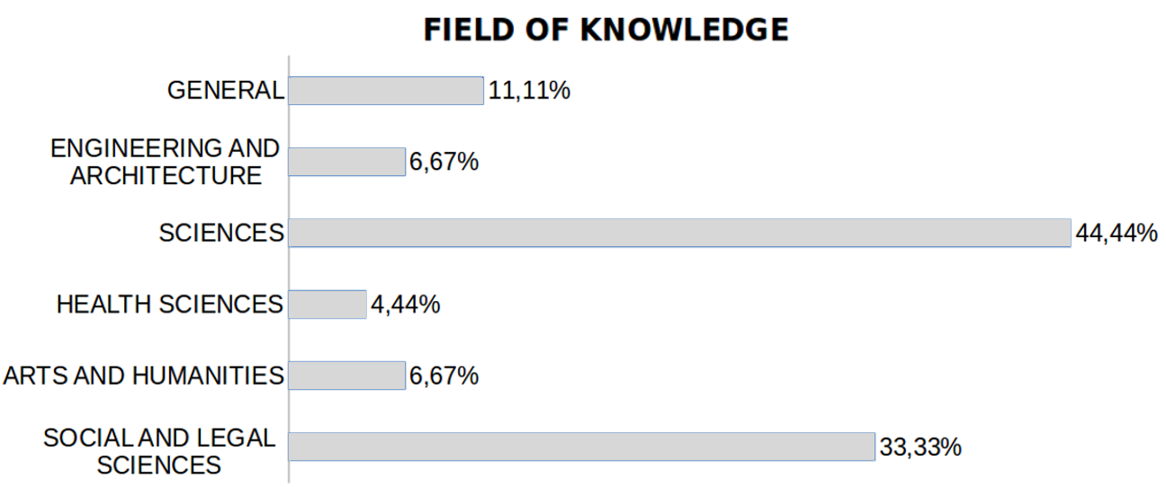

In relation to the instructional designs, different approaches were observed. In this regard, the distribution of participants usually plays an essential role. More than 30% of the analyzed investigations separated students into small groups (2-5 classmates). Groups’ assignment was mainly random, but there were papers where teachers allocated students to groups to help their teammates (e. g. Lai & Law, 2013). On the other hand, more than 22% of the contributions put all the classmates together to share ideas and used small groups to improve ideas, provide accurate definitions, and solve the proposed tasks. This design was applied, for instance, by Hong (2014). There are also mixed approaches, so that groups did part of the work, and the rest of the activities were done individually, as in the case of Kimmerle, Moskaliuk, Brendlec & Cress (2017). In addition, researchers who took advantage of blended designs were also found. These authors combine face-to-face with virtual environments, so that ideas created in the face-to-face sphere were discussed within the virtual community afterwards (e. g. Gutiérrez-Braojos, 2020). The role of the teachers is also a discussed issue with regard to teaching methods, and more than 17% of the contributions emphasized that they acted as a guide, either posing a question at the beginning of the course or supervising the evolution of the work.

Finally, distribution of sessions is an interesting variable related to instructional design. Because it is common to work within a virtual environment, researchers usually spent several sessions introducing this environment. Likewise, some of the reviewed investigations divided teaching into phases in order to separate ideas or contents.

At this point it must be emphasized the essential role of technology when taking advantage of the KB pedagogy. Indeed, it was found out that all the empirical research papers made use of technological tools to design learning experiences. The Knowledge Forum (KF) environment was mostly used (over half of the cases). There are other approaches based on platforms such as Moodle (e.g. Porcaro, 2014), Etherpad (e.g. Kimmerle, Moskaliuk, Brendlec & Cress, 2017), Web Padlet (e.g. Zhi & Mu, 2015), Wiki environments (e.g. Li, Tang & Shi, 2015) or social networks such Elgg (e.g. Tammets, Pata & Laanpere, 2013), but they make up a minority. Teachers also work with Wikipedia (e.g. Oeberst, Halatchliyski, Kimmerle & Cress, 2014) in order to work on a specific goal.

Methodology employed in the research on Knowledge Building

With regard to the research methods, a general tendency to combine both quantitative and qualitative approaches was found. Specifically, there was a prevalence of mixed studies (72%) that took advantage of both types of strategies for gathering and analyzing data. By contrast, only 18% of the considered contributions were purely qualitative, and 11% were only quantitative. As for the research design, 53% of the papers contemplated experimental or quasi-experimental studies. Some of them were based on a pretest and post-test design with (11%) or without a control group (24%), whereas the remaining 18% were exploratory examinations. Methodological approach in these investigations was transversally concerned with analyzing the effects of technology. However, there were contributions that focuses on check the importance of technology. In this sense, different kind of analyses were encountered: studies of case (e.g. Hong & Scardamalia, 2014), where different components of KB were taken into account; comparative studies to investigate the effects of instructional designs (e.g. Hong, 2014; Hong & Chai, 2017); or examinations between differences between experimental and control groups (e.g. Hong, Chang & Chai, 2014; Resendes, Scardamalia, Bereiter, Chen & Halewood, 2015). These papers observed the efficacy of technological tools.

As for the analysis processes, three differentiated trends could be identified: (i) content analysis that categorized records of students' contributions in the virtual platform and codified the main ideas in order to get their results; (ii) analysis of social networks in order to understand personal relationships that arose in relation to the use of virtual environments; and (iii) descriptive and inferential statistical analyses. Strategies for data gathering employed in the checked contributions depended on the type of research performed (Figure 6, on the left). The most usual procedures were associated with specific instruments. Specifically, 58% of the cases used tools such as closed item questionnaires, surveys, scales, tests or rubrics. Some of them were already validated, such as the Creative Climate Questionnaire (e.g. Lee & Yoo, 2020; Costello, 2020; Comes, Cavalcante & Toda, 2020) or the Knowledge-Building environment scale (e.g. Avcı, 2020; Ghazal, Al-Samarraie & Wright, 2019; MacLeod & Yang, 2018; Wu & Wang, 2016), but there were also adapted instruments and even original ones. Apart from these, the reviewed research on Knowledge Building made use of three other procedures. The first one is based on observation through checklists, audio, or video records, and it was used by 18% of the considered studies. Another 15% used structured or semi-structured interviews, most of them with the aim of confirming or explaining quantitative results. Finally, a few of the reviewed contributions conducted focus groups or completed document review processes (7% and 4% of the sample, respectively) to complement information.

FIGURE 6. Strategies for data gathering and duration of the studies carried out in the studies of the analyzed sample.
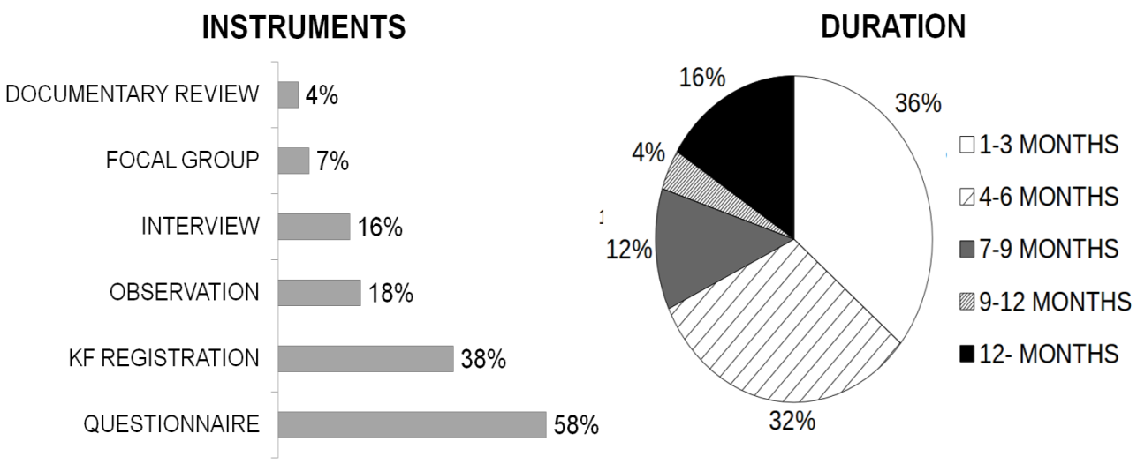

Concerning the time invested in developing the investigations, the research is mainly designed around one specific course and subject. Indeed, almost 36% of the analyzed studies took between 1 and 3 months, and only 16% can be considered long-lasting investigation (more than 1 year). The full distribution of the research durations is shown in figure 6 (right).

Results of the research on Knowledge Building

Content analysis applied to research findings of the analyzed sample led to a four-dimensional scheme of the effects of putting KB pedagogy into practice (Figure 7, left). These results refer not only to benefits for students’ learning but also to the importance of technology for enhancing learning processes and theoretical aspects about KB.

The first dimension concerns the improvement of students’ collaborative learning skills. Social competences related to collaboration, active participation, collective reflection and communication resulted to be enhanced by using KB. Authors point out that these skills contribute to make community knowledge building easier. 60% of the sample exposed the development of collaborative learning skills. Some of them are Oeberst, Halatchliyski, Kimmerle & Cress (2014), Hong, Chang & Chai (2014), Chen, Scardamalia & Bereiter (2015), Lin, Hong & Chai (2014) and Kimmerle, Moskaliuk, Brendlec & Cress (2017). The second category of benefits is composed of active learning abilities. Personal skills were also improved through the KB pedagogy and the use of virtual environments. These competences include higher motivation to discuss and learn, more interest in the topics of discussion, greater creativity, development of informal learning processes, greater adaptation to this kind of methodologies, and greater responsibility of students with advancing in shared knowledge. Benefits related to this second dimension are reported in 44% of the analyzed contributions, for instance Goh, Chai & Tsai (2013), Hong, Chang & Chai (2014), Hong, (2014), Gutiérrez-Braojos & Salmeron-Pérez (2015), and Chen (2017). The third dimension is related to metacognitive development of students. Research shows that the implementation of KB leads to the improvement of learning to learn skills: creation of deeper discourses, use and development of scaffolds to generate more complex ideas, capacity of asking and answering higher level questions, acquisition of specialized vocabulary, reflective self-assessment and ability to create knowledge to solve real problems. 55% of the reviewed papers encountered gains in this category, among them Lai & Law (2013), Hong & Scardamalia (2014), Lin, Hong & Chai (2014), Hong, Chang & Chai (2014) and Cacciamani (2017). The fourth category remarks the importance of technology to apply and develop theory of KB. It includes is not related to learning processes, but in the effect of using technological tools such as KF environment on such learning processes. This dimension also includes conclusions regarding theoretical aspects of the pedagogy. Although results related to this dimension were explicit in only 13.33% of the contributions in the sample (e.g. Oeberst, Halatchliyski, Kimmerle & Cress, 2014; Porcaro, 2014; and Li, Tang & Shi, 2015), it is noticeable that this kind of conclusions are transversal to the majority of studies on KB.

FIGURE 7. Benefits of applying Knowledge Building pedagogy found (on the left) and limitations pointed out by authors (on the right) of the analyzed sample.
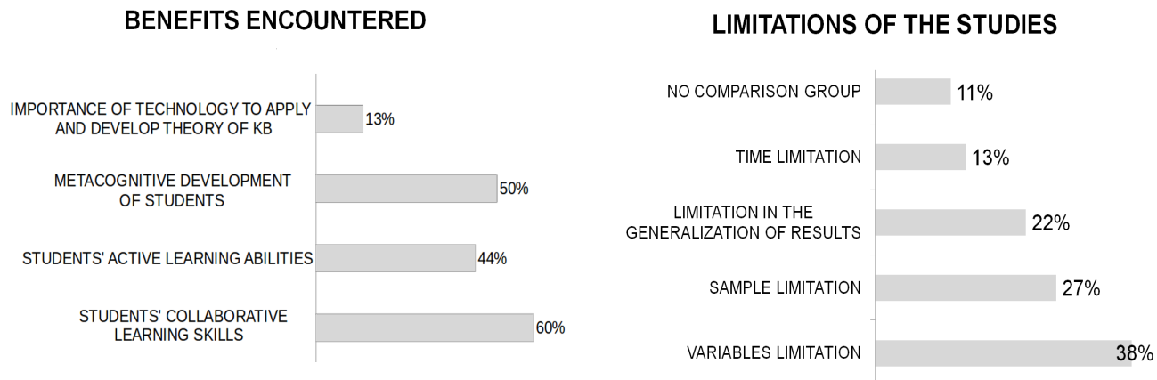

As for limitations pointed out by authors, Figure 7 (right) describes the most important ones. Researchers were mainly concerned with limitations involving the employed variables. Thus, 38% of the investigations highlighted authors' uncertainty about links between results and the influence of uncontrolled variables such as context, students' previous knowledge, or teachers' training, among others. In particular, there were studies that expressed their concerns about the absence of a control group, which could help to control these variables. In this regard, some of these authors made explicit the small number of variables taken into account compared to those they considered relevant in addressing the research objectives. Limitations related to the sample (27% of the reviewed papers) and, therefore, the inability to generalize the findings (22%) were also two weaknesses emphasized by researchers. Likewise, duration of studies is considered a limitation by 13% of the contributions, given that most of the investigations were lasted less than 9 months, and the authors were aware that this is not enough time to corroborate long-lasting results.

Conclusion

Knowledge Building is a dynamic and proper pedagogy to facilitate learning environments that encourage students to move beyond knowledge reproduction. This is based on the two complementary studies using mixed methods carried out in this work.

On one hand, a time-based analysis regarding the researchers on KB has been performed. This kind of study is a novelty not only for this pedagogy but also in the field of education. The results indicate that KB can be considered a groundbreaking topic of research in continuous improvement and with a relatively fast growth. Also the KB shows a high degree of coherence and a considerable scientific and technological impact (Cozzens, et al., 2010; Small, Boyack & Klavans, 2014). The diachronic analysis shows that productions per year are increasing. Moreover, classical scientometric laws to estimate authorship do not fit due to an imbalance between prolific and less productive authors. In particular, the square root law nor Pareto’s principle for individuals were fulfilled for the same reason: they predict less concentrated distributions of authorships than the empirically observed ones. Likewise, classical a priori estimations about these distributions, such as Price's law, also usually fail. This is due to the set of researchers who contributed one paper in the studied period. These results match with findings of Fernández-Cano, Torralbo and Vallejo, (2004) which show that Price´s law is not fulfilled in studies which analyze short periods of time. Regarding consumption and collaboration, the most impacting papers are produced by two strong groups. Finally, the dynamics of authorships show a small number of core publishing authors, very high levels of transience, and moderate levels of continuance. These results can be explained from the period covered by this study, only 5 years. Assuming this, the scientometric findings sketch a dynamic publishing population typical of an up and coming research field.

The systematic review provides an outlook on the most relevant research approach and educational impact concerning Knowledge Building Pedagogy. Most of the checked studies applied mixed methods that offer more guaranteed results. Hence, results of such studies provide signs of the benefits of Knowledge Building pedagogy: it improves the ability to build knowledge, allows students to provide deeper contributions in the virtual environment, and promotes collaboration among them to share objectives, become more independents from teachers, and show better attitudes towards subjects. Most of the analyzed investigations are local, consider small samples, and sometimes they lack a control group. This is reasonable when the studies respond to a qualitative research methodology or a complex research methodology, such as mixed research. While it is important to note that the PKB carried out research on a wide range of topics, contexts, cultures and educational levels, and there is consistency among all the documents reviewed on the effects of PKB, i.e., this leads to an improvement in the creation of concept and higher psychological functions of students in classroom.

Two key conclusions underlying these results are obtained. Firstly, the relevance of technology for KB in regard to teachers’ design of learning experiences. Indeed, every single investigation in the analyzed sample took advantage of some software program o virtual environment during the implementation of the pedagogy. This makes clear that the creation of shared ideas is suitably supported by these technological tools (e.g. KF). Thus, innovative teaching based on KB is actually linked to the use such tools. Furthermore, as founded in the qualitative analysis, recent research supports that knowledge building processes based on computers allow achieving students’ learning gains. Secondly, it was found that evaluating learning improvements or the importance of technology entails advancements in theoretical and methodological aspects, in such a way that research is also an effective tool to reflect on the KB theory as well as on their implementation.

Considering future studies from the results of the systematic review, it can be concluded that researchers also point out that it is necessary to include more variables, employ greater samples, and increase the duration of the research in future research on KB. These changes will make it possible to control direct effects of KB pedagogy, as well as the generalization of the results. Moreover, it must be emphasized that social aspects like the transcendence of KB philosophy beyond schools and socio-affective health in KB communities have to be studied more in depth by the research.

There are also some limitations of the study that should be remarked. First of all, a five-year period may be a short time to find scientometric regularities, which may be fulfilled in the long term. Therefore, the reader should carefully interpret the data regarding to the Price´ laws. Moreover, only the WoS database has been taken into account, and a broader analysis would have provided more faithful results.

To conclude, it should be emphasized that this investigation is only interested in Knowledge Building. It is a very accurate research topic, and there is no systematic procedure to search for related papers. As indicated, several filtering processes were performed to choose the contributions to take into account, but it is not necessarily true that the whole relevant investigation is included. Thus, further studies are encouraged to reach a deeper insight about research in KB, including different databases, systematic recruitment processes of papers and a network analysis about co-production.

Final note 1: The “square root” law (Price, 1963)
This law provides a quantitative estimation of the contribution of the large producers to the total amount of publications in a scientific discipline. Price (1963) noted that the contribution of a large number of low producers was comparable to that of a small number of large producers and conjectured that the number of such large producers was the same order of magnitude as the square root of the total number of authors. This conjecture can be summarized in a nutshell: 50% of the papers are produced by the square root of the number of authors.

Final note 2: Cumulative Advantage Models (Price, 1976)
This is a family of mathematical models to estimate the distribution of authorship in a scientific discipline. Lotka's Law (1927) establishes that the percentage of individuals who produce n papers is proportional to 1/n². Price (1976) noted that in scientometrics, as in other social phenomena, success seems to breed success (what is so-called Matthew effect (Merton, 1968; 1998), but Lotka’s model did not include this effect. In order to introduce this cumulative advantage in the estimation of the % of the authors who produce n papers, Price (1976) developed a family of probability functions depending on a numerical parameter m, which can be chosen to optimize the estimates. These cumulative advantage models were used in this paper in comparison to empirical data and other estimation. Further details about the mathematical functions and the derivation of the family of models can be found in Price (1976).

References

Aliaga, F. M. (1999). Análisis de correspondencias: estudio bibliométrico sobre su uso en la investigación educativa. RELIEVE-Revista Electrónica de Investigación y Evaluación Educativa, 5(1).

Aliaga, F. M., Gutiérrez-Braojos, C. & Fernández-Cano, A. (2018). Research journals in education: SWOT Analysis. Revista de Investigación Educativa, 36(2), 563-579.

Avcı, Ü. (2020). Examining the role of sentence openers, role assignment scaffolds and self-determination in collaborative knowledge building. Educational Technology Research and Development, 68(1), 109-135.

Bereiter, C (2002). Education and mind in the knowledge age. London: Lawrence Erlbaum.

Bereiter, C. (2014). Principled practical knowledge: Not a bridge but a ladder. Journal of the Learning Sciences, 23(1), 4-17.

Bereiter, C., & Scardamalia, M. (1987). An attainable version of high literacy: Approaches to teaching higher-order skills in reading and writing. Curriculum Inquiry, 17(1), 9-30.

Bereiter, C., & Scardamalia, M. (1993). Surpassing ourselves: An inquiry into the nature and implications of expertise. Chicago: Open Court.

Bueno, Á., & Fernández-Cano, A. (2003). Análisis cientimétrico de la productividad en la Revista de Investigación Educativa (1983-2000). Revista de Investigación Educativa, 21(2), 507-532.

Cacciamani, S. (2017). Experimental learning and knowledge building in higher education: An application of the progressive design method. Journal of e-Learning and Knowledge Society, 13(1). 27-38. DOI: 10.20368/1971-8829/1245

Chen, B. (2017). Fostering scientific understanding and epistemic beliefs through judgments of promisingness. Educational Technology Research and Development, 65(2), 255-277. DOI: 10.1007/s11423-016-9467-0

Chen, B., & Hong, H. Y. (2016). Schools as knowledge-building organizations: Thirty years of design research. Educational Psychologist, 51(2), 266-288.

Chen, B., Scardamalia, M., & Bereiter, C. (2015). Advancing knowledge‐building discourse through judgments of promising ideas. International Journal of Computer-Supported Collaborative Learning, 10(4), 345-366. DOI: 10.1007/s11412-015-9225-z.

Comes, M., Cavalcante, F., & Toda, F. (2020). Avaliação do clima organizacional de suporte à criatividade e inovação em programas de pós-graduação stricto sensu. Revista Ciências Administrativas ou Journal of Administrative Sciences, 26(1), 1-16.

Costello, G. (2020). Teaching of Design and Innovation. Suiza: Springer Nature.

Creswell, J. W. (2013). Research Design: Qualitative, Quantitative, and Mixed Methods Approach. Thousand Oaks, CA: Sage.

Cozzens, S., Gatchair, S., Kang, J., Kim, K.S., Lee, H.J., Ordóñez, G., & Porter, A. (2010). Emerging technologies: quantitative identification and measurement. Technology Analysis & Strategic Management, 22, 361–376.

Fernández, A. D., Ruiz-Corbella, M., & Galán, A. (2017). Calidad editorial y científica en las revistas de educación. Tendencias y oportunidades en el contexto 2.0. Revista de Investigación Educativa, 35(1), 235-250.

Fernández-Bautista, A., Torralbo, M., & Fernández-Cano, A. (2014). Análisis longitudinal de tesis doctorales españolas en educación (1841-2012). RELIEVE-Revista Electrónica de Investigación y Evaluación Educativa, 20(2).

Fernández-Cano, A., Torralbo, M. & Vallejo, M. (2004) Reconsidering Price's model of scientific growth: An overview. Scientometrics, 61, 301–21.

Fonseca-Mora, M. C., & Aguaded, I. (2014). Las revistas científicas como plataformas para publicar la investigación de excelencia en educación: estrategias para atracción de investigadores. RELIEVE-Revista Electrónica de Investigación y Evaluación Educativa, 20(2).

Ghazal, S., Al-Samarraie, H., & Wright, B. (2019). A conceptualization of factors affecting collaborative knowledge building in online environments. Online Information Review, 44(1), pp. 62-89. https://doi.org/10.1108/OIR-02-2019-0046

Goh, A., Chai, C. S., & Tsai, C. C. (2013). Facilitating students’ development of their views on nature of science: A knowledge building approach. The Asia-Pacific Education Researcher, 22(4), 521-530. DOI: 10.1007/s40299-012-0050-0.

Goldman, S. R., & Scardamalia, M. (2013). Managing, understanding, applying, and creating knowledge in the information age: Next-generation challenges and opportunities. Cognition and Instruction, 31(2), 255-269.

Gutiérrez-Braojos, C. (2020, March). A sequence for the Knowledge Building Pedagogy. Knowledge Building International. Retrieved from https://ikit.org/kbi/index.php/news/

Gutierrez-Braojos, C., Martín-Romera, A., Casasempere, A., & Fernández Cano, A. (2015). Análisis Cientimétrico de la Grounded Theory en Educación. Revista de Educación, 370 (Octubre-Diciembre), 121-148.

Gutiérrez-Braojos, C., Martín-Romera, A., Salmerón-Pérez, H., Casasempere, A., & Fernandez Cano, A. (2017). Análisis temático de la investigación educativa soportada por Grounded Theory. Bordón. Revista de Pedagogía, 69(1), 83-102.

Gutiérrez-Braojos, C., Montejo-Gámez, J., Ma, L., Chen, B., de Escalona-Fernández, M. M., Scardamalia, M. & Bereiter, C. (2019). Exploring collective cognitive responsibility through the emergence and flow of forms of engagement in a knowledge building community. In L.D. (Ed). Didactics of Smart Pedagogy (pp. 213-232). Nueva York: Springer.

Gutiérrez-Braojos, C., Montejo-Gamez, J., Marín-Jiménez, A. & Campaña, J. (2019). Hybrid learning environment: Collaborative or competitive learning? Virtual Reality, 23(4), 411-423.

Gutiérrez-Braojos, C., Montejo-Gámez, J., Marín-Jiménez, A. E. & Poza-Vilches, F. (2018). A Review of Educational Innovation from a Knowledge-building Pedagogy Perspective. In A.V., M.L., L.D. (Eds), The Future of Innovation and Technology in Education: Policies and Practices for Teaching and Learning Excellence, (41-54). Melbourne: Emerald Publishing Limited.

Gutiérrez-Braojos, C., Montejo-Gámez, J., & Poza-Vilches, F. (August 2018). That’s an impactful idea: Using peer citation to explore collective responsibility for knowledge advancement. Poster presented at the 22nd Knowledge Building Summer Institute; Toronto, Canada.

Gutiérrez-Braojos, C. & Salmerón-Pérez, H. (2015). Exploring collective cognitive responsibility and its effects on students' impact in a knowledge building community. Infancia y Aprendizaje. Journal for the Study of Education and Development, 38(2), 327-367.

Halatchliyski, I., Moskaliuk, J., Kimmerle, J., & Cress, U. (2013). Explaining authors’contribution to pivotal artifactsduring mass collaboration in the Wikipedia’s knowledge base. International Society of the Learning Sciences. Nueva York: Springer.

Hong, H. Y. (2014). Developing student-centered teaching beliefs through knowledge building among prospective teachers. In Tan, S., So, H., and Yeo (Eds), Knowledge creation in education (pp. 189-204). Springer, Singapore. DOI: 10.1007/978-981-287-047-6_11.

Hong, H-Y., & Chai, C.S. (2017). Principle-based design: Development of adaptive mathematics teaching practices and beliefs in a knowledge building environment. Computers & Education, 115, 38-55. DOI: 10.1016/j.compedu.2017.07.011.

Hong, H-Y., Chang, Y-H., & Chai, C.S. (2014). Fostering a collaborative and creative climate in a college class through idea-centered knowledge-building. Instructional Science, 42(3), 389-407. DOI: 10.1007/s11251-013-9289-y.

Hong, H. Y., & Scardamalia, M. (2014). Community knowledge assessment in a knowledge building environment. Computers & Education, 71, 279-288.

Kimmerle, J., Moskaliuk, J., Brendle, D., & Cress, U. (2017). All in good time: Knowledge introduction, restructuring, and development of shared opinions as different stages in collaborative writing. International Journal of Computer-Supported Collaborative Learning, 12(2), 195-213. DOI: 10.1007/s11412-017-9258-6.

Kimmerle, J., Moskaliuk, J., Oeberst, A., & Cress, U. (2015). Learning and collective knowledge construction with social media: A process-oriented perspective. Educational Psychologist, 50(2), 120-137.

Lai, M. & Law, N. (2013) Questioning and the quality of knowledge constructed in a CSCL context: A study on two grade-levels of students. Instructional Science, 41(3), 597-620. DOI: 10.1007/s11251-012-9246-1.

Lee, Y., & Yoo, S. (2020). Individual profiles and team classes of the climate for creativity: A multilevel latent profile analysis. Creativity and Innovation Management; 1-15. DOI: 10.1111/caim.12371,

Li, S., Tang, Q., & Shi, P. (2015). Learning analysis on learners’ wiki-based collaborative knowledge building behaviors. In G. Chen, V. Kumar, Kinshuk, R. Huang, & S. C. Kong (Eds.), Emerging Issues in Smart Learning (pp. 217-224). Berlín: Springer Verlag. DOI: 10.1007/978-3-662-44188-6_30.

Lin, K.Y., Hong, H-Y., & Chai, C. S. (2014). Development and validation of the knowledge-building environment scale. Learning and Individual Differences, 30, 124-132. DOI: 10.1016/j.lindif.2013.10.018.

Lotka, A. (1926). The frequency distribution of scientific productivity. Journal of the Washington Academy of Sciences, 16(12), 317-323.

MacLeod, J., & Yang, H. H. (2018). Intercultural computer-supported collaborative learning: Theory and Practice. In digital technologies and instructional design for personalized learning, (pp. 80-97). Hershey: IGI Global.

Merton, R. K. (1968). The Matthew effect in science: The reward and communication systems of science are considered. Science, 159(3810), 56-63.

Merton, R. K. (1988). The Matthew effect in science, II: Cumulative advantage and the symbolism of intellectual property. ISIS, 79(4), 606-623.

Moher, D. A. & Liberati, A. (2010). Revisiones sistemáticas y metaanálisis: la responsabilidad de los autores, revisores, editores y patrocinadores. Med Clin (Barc), 135, 505-506.

Muhonen, H., Rasku-Puttonen, H., Pakarinen, E., Poikkeus, A. & Lerkkanen, M. (2017). Knowledge-building patterns in educational dialogue. International Journal of Education Research, 81, 25-37. DOI: 10.1016/j.ijer.2016.10.005.

Oeberst, A., Halatchliyski, I., Kimmerle, J., & Cress, U. (2014). Knowledge construction in Wikipedia: A systemic-constructivist analysis. Journal of the Learning Sciences, 23(2), 149-176. DOI: 10.1080/10508406.2014.888352.

Park, H., & Park, H. W. (2018). Two-side face of knowledge building using scientometric analysis. Quality & Quantity, 52(6), 2815-2836.

Paavola, S & Hakkarainen, K. (2005). The knowledge creation metaphor – An emergent epistemological approach to learning. Science & Education, 14, 537-557.

Popper, K. R. (1972). Objective knowledge (Vol. 360). Oxford: Oxford University Press.

Popper, K. (1994). Knowledge and the mind-body problem: In defence of interaction. (Vol. 134). Londres y Nueva York: Routledge.

Porcaro, D. (2014). Educational change in Oman: a design research study of personal, institutional, and societal reactions to collaborative Knowledge Building. Technology, Pedagogy and Education, 23(2), 199-203. DOI: 10.1080/1475939X.2013.802993.

Price, D. de S. (1963). Little science, big science. Nueva York: Columbia University Press.

Price, D. de S. (1976). A general theory of bibliometrics and other cumulative advantage processes. Journal of the American Society for Information Science, 27(5-6), 292-306.

Price, D. de S. (1986). Little science, big science... and beyond. Nueva York: Columbia University Press.

Resendes, M., Scardamalia, M., Bereiter, C., Chen, B., & Halewood, C. (2015). Group-level formative feedback and metadiscourse. International Journal of Computer-Supported Collaborative Learning, 10(3), 309–336. DOI: 10.1007/s11412-015-9219-x.

Rodríguez Gómez, G., Gil Flores, J., & García Jiménez, E. (1996). Metodología de la investigación cualitativa. Ediciones Aljibe. Granada, España.

Roscoe, R. D. (2014). Self-monitoring and knowledge-building in learning by teaching. Instructional Science, 42(3), 327-351.

Scardamalia, M. (2002). Collective cognitive responsibility for the advancement of knowledge. Liberal education in a knowledge society, 97, 67-98.

Scardamalia, M. (2004). CSILE/Knowledge forum®. Education and technology: An encyclopedia, (183-192). Santa Barbara: ABC-CLIO.

Scardamalia, M., & Bereiter, C. (1994). Computer support for knowledge-building communities. The Journal of the Learning Sciences, 3(3), 265-283.

Scardamalia, M., Bereiter, C. & Lamon, M. (1994). CSILE: Trying to bring students into world 3. In K. McGilley (Ed.), Classroom lessons: Integrating cognitive theory and classroom practice (pp. 201–228). Cambridge, MA: MIT Press.

Scardamalia, M., & Bereiter, C. (2017). Two modes of thinking in Knowledge Building. Revista Catalana de Pedagogía, 12, 61-83.

Small, H., Boyack, K.W., & Klavans, R. (2014). Identifying emerging topics in science and technology. Research Policy, 43, 1450–1467.

Tammets, K., Pata, K., & Laanpere, M. (2013). Promoting teachers’ learning and knowledge building in the socio-technical system. The International Review of Research in Open and Distance Learning 14(3), 251-272. DOI: 10.19173/irrodl.v14i3.1478.

Thagard, P. (1989). Explanatory coherence. Behavioral and brain sciences, 12(3), 435-467.

Von Hippel, E. (2005). Democratizing innovation: The evolving phenomenon of user innovation. Journal für Betriebswirtschaft, 55, 63–78.

Wu, Y. T., & Wang, L. J. (2016). Research trends in technology-enhanced knowledge building pedagogies: a review of selected empirical research from 2006 to 2015. Journal of Computers in Education, 3(3), 353-375.

Zhi, Q., & Su, M. (2015, October). Enhance collaborative learning by visualizing process of knowledge building with Padlet. In 2015 International Conference of Educational Innovation through Technology (EITT) (pp. 221-225). IEEE. Wuhan (China). DOI: 10.1109/EITT.2015.54.

